Technical data of dry Transformer
- Power 630 kV type ТСЗ 630/10
- The nominal voltage of TR is 10/0.4 kV
- The nominal current of TR is 36.4/909 A
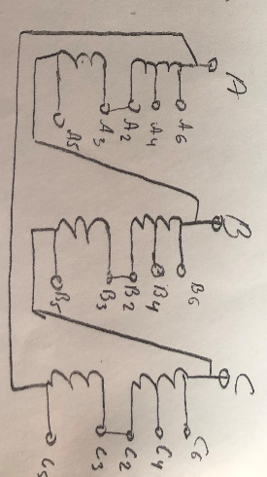
- Connection group
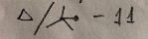
- Voltage Regulation ПБВ +- 5%

 | H/V | L/V
1 | 10 500 | 400 V
2 | 10 250
3 | 10 000
4 | 9 750
5 | 9 500

- 6. Frequency 50 Hz
- 7. Short-circuit voltage Uk%-7.07% - permissible difference within +- 10%
- 8. The output of high and low voltage windings should be on the racks
- 9. Outputs of high voltage windings should be placed horizontally in the upper part of the transformer.
- 10. Outputs of low voltage windings should be arranged vertically in the upper part of the transformer and neutral output should be installed above phase outputs.
- 11. The transformer should be enclosed in a protective casing
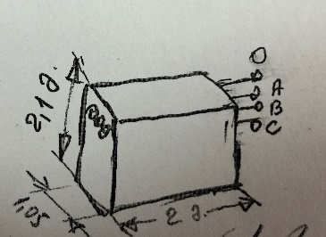
- Casing dimensions are: 2X2.1X1.05 m

13. The winding of the transformer should preferably be made of copper, but the option of aluminum is also considered. (with thermal insulation)
14. Transformer insulation, lightened (so-called dry) insulation thermal resistance class "В"
15. The transformer must work underground, in a closed space, it must be of moisture-resistant so-called tropical performance.
16. Altitude 1000 m above sea level

